[Your Name] [Applied Position]
[Your Address][Your Email][Your Phone]

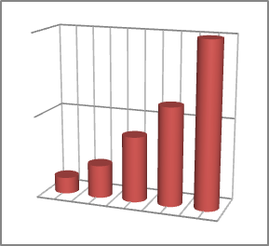 Objective
State briefly, your short and long-range career goals and try not to be cliché

 Experience
[Company Name][Location]  [Last Position]  [Most recent/current job]  [Begin with most recent company first, range or working years, job title, job description, accomplishment of duties. Write corresponding accomplishment with your expected job] | [Year]
[Company Name][Location]  [Position]  [Job 2] | [Year]
[Company Name][Location]  [Position]  [Job 3] | [Year]

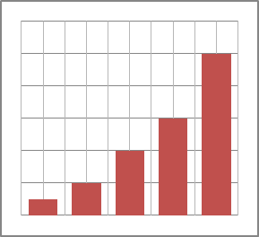 Education
[Last School Name][Location]  [Last Degree]  [Begin with most recent degree first, major field of study, date of graduation, certificate awarded. If applicable, it should include thesis title or publications] | [Year]
[School Name 2][Location]  [Degree 2] | [Year]

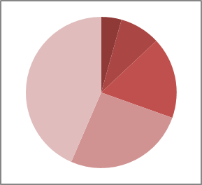 Activities
[Activities][Location]  [Most recent activities]  [State position, organization, dates and your activities description] | [Year]
[Activities][Location]  [Activities 2] | [Year]

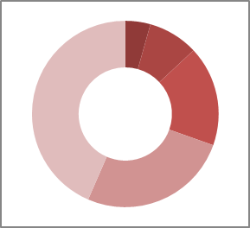 Training, Certification, Skills
[List special skills, training, or certification that will raise your value for your expected job. For example, foreign language fluency, knowledge of computers or other office machines, special equipment or other special talents that are relevant]

 References
[State "Available upon request" or list names, titles and companies, academic or character references]

