A College Essay Format For Students
You can have a great story, but you will fail without a proper formatting. There are a few things to consider:
- Use 12 Font, You can choose either Times New Roman or Arial;
- Use double spacing;
- Use one-inch margin from all the sides;
- Put your title in the middle of the page;
- Align your text to the left side;
- Start every new paragraph with an intended line.
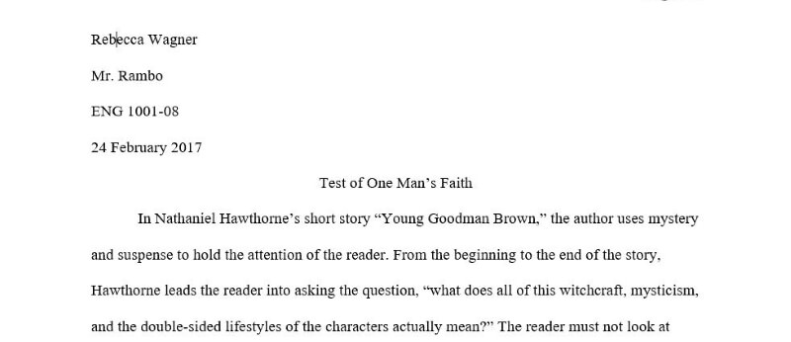

How to write a good college essay
The first thing to find out after you get the task from your tutor is how long should a college essay be. If you need to write a one-page text, you will spend about three days on doing the task. If you have to write about 5 pages, you will need more time. Once you know the number of pages, you can start preparation. Here are a few steps for you to follow.

Choose the topic
Your goal is to make readers interested in your essay. You can ask a question or write a controversial statement. The more thoughts your topic will evoke the more impressive essay you will have. If you have no college essay ideas for the topic, write down a list of common problems that are related to the course that you’re taking.
Here are a few argumentative essay topics for college students:
- A dream city where you would like to live in.
- The most prominent novel of the 20th century: the influence of literature on society.
- The key features of the democracy today and one hundred years ago.
- Keep it simple: healthy way of living is available for everyone.
- Five reasons to start a career in IT industry.

Write an outline
It’s a detailed plan of the text where you will put all your ideas, quotations into the right position. Develop a thesis statement that you will put at the end of the first paragraph. It should represent the core idea of the paper and the arguments that you will write in the body part. An outline should include all the quotations if you plan to use them as the evidence for your arguments or for your personal position towards the topic.
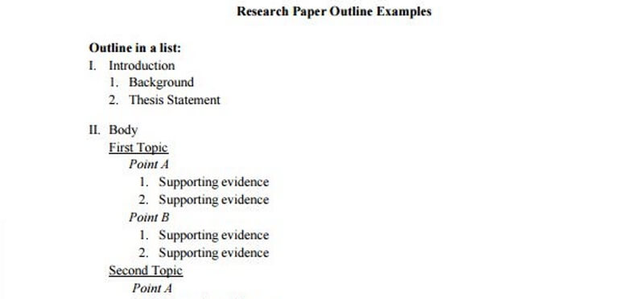

Write the text
When you have your outline ready, it’s time to develop it into the text. Start writing without thinking about formatting or mistakes. You will correct everything after you finish. If you focus on the format and the correctness of your writing, you will spend much more time o writing. You know how to format a college essay, so focus on the context first.
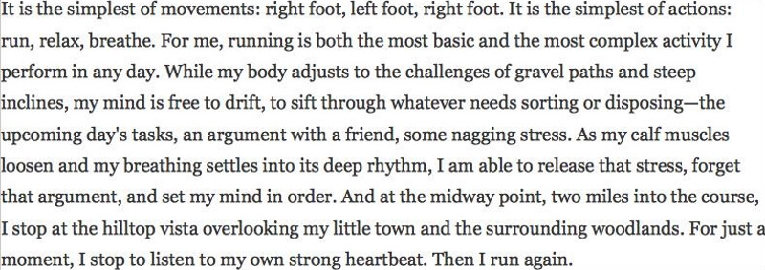

Add finishing touches
When you have your text ready, put it away for a while. Let your brain forget the text and have some rest. When you come back to checking what you have written, you will easily notice even the slightest mistakes. Take a look at the visual appearance of the text and try to exclude all the mistakes that you can find.

