In Memory Of
On this special day we wish to remember those who cannot be here with us in person, but who are here in spirit, including:

Margie Hayne (Mother of the Groom)

You are in our hearts always; we love and miss you.


No Photos Please

We want you to be able to relax and have fun with us today, so we kindly ask that you please leave your camera in your bag during the ceremony, and put your cell phone on mute.
We're happy to share our professional wedding photos later, but the greatest gift you can give us today is just being fully here with us in this sacred and special moment.
Thank You
Thank you to our family and friends for
choosing to celebrate this day with us and for honoring us with your presence and love.

After the ceremony, please join us at the Antigonish Legion to continue the celebration. Grand Entrance will be at 7:30pm.

LAURA & JOSHUA

ARE TYING THE KNOT
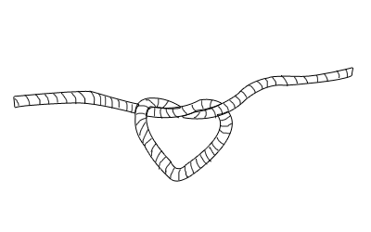
(But you probably figured that out by now)

October 12, 2013
6:00 pm

St. Paul the Apostle Anglican Church
Antigonish, NS

Here’s how it’s going to go:

PROCESSIONAL OF THE BRIDAL PARTY

PROCESSIONAL OF THE BRIDE

OPENING PRAYER

LITURGY OF THE WORD

READING
1 Corinthians 13: 4-13, Name of Reader

READING
Hope is the Thing with Feathers, Emily Dickenson, Name of Reader

GOSPEL

HOMILY

RITE OF MARRIAGE

EXCHANGE OF VOWS

BLESSING & EXCHANGE OF RINGS

SIGNING OF THE REGISTRY

PRAYER OF THE PEOPLE

LORD’S PRAYER

BLESSING OF THE MARRIAGE

PEACE

POSTLUDE

PARENTS OF THE BRIDE
Sheldon and Michele Fiander

PARENTS OF THE GROOM
Eric and the Late Margie Hayne

OFFICIANT
The Reverend Rebecca Sample

ORGANIST
Lisa Morrow-DeCoste

USHERS
Jordan Fiander (Niece of the Bride)
Jayden Fiander (Niece of the Bride)

